### PRACTICAL NO 5

**AIM:** Analysis of Variance

### # CREATE THE DATA IN TO THREE GROUPS

> group1=c(2,3,7,2,6)

> group2=c(10,8,7,5,10)

> group3=c(10,13,14,13,15)

>cg=data.frame(cbind(group1,group2,group3))

>cg

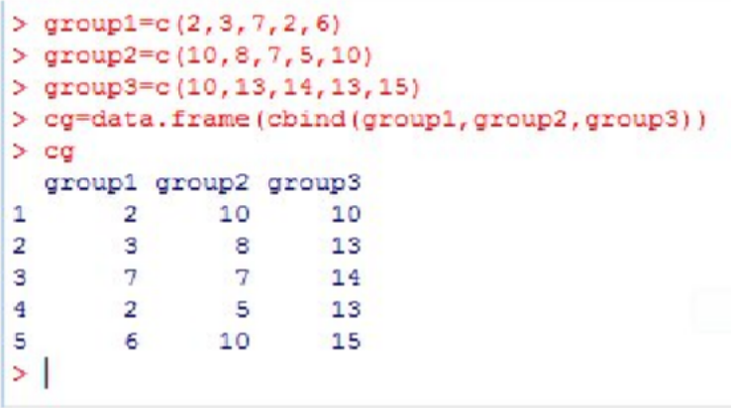

### #TO PRINT THE SAME DATA INTO .CSV FORMAT

>write.csv(cg,"D:/cg.csv")

>summary(cg)

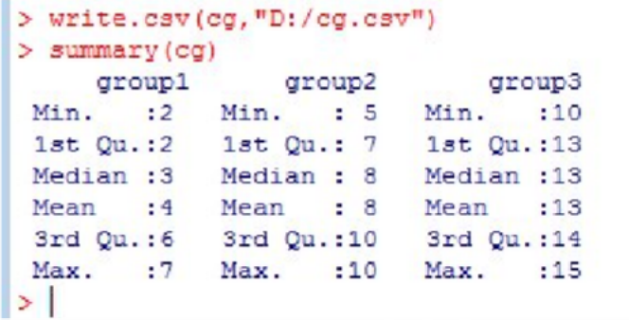

### #TO PRINT THE BOXPLOT

>boxplot(cg)

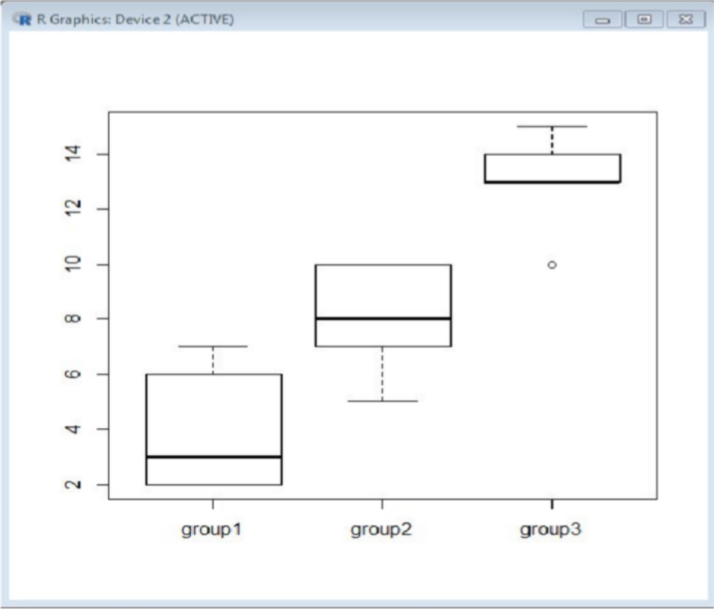

### #TO PRINT THE DATA INTO STACK FORMATE

>stacked_g=stack(cg)

>stacked_g

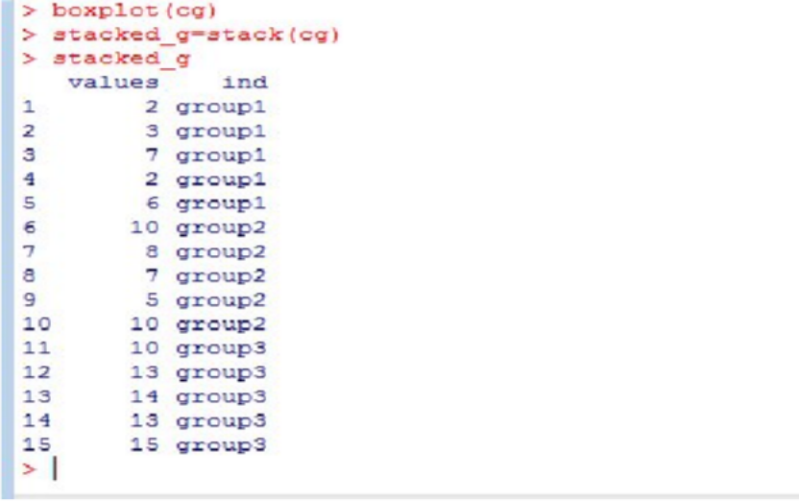

>av=aov(values~ind,data=stacked_g)

>summary(av)

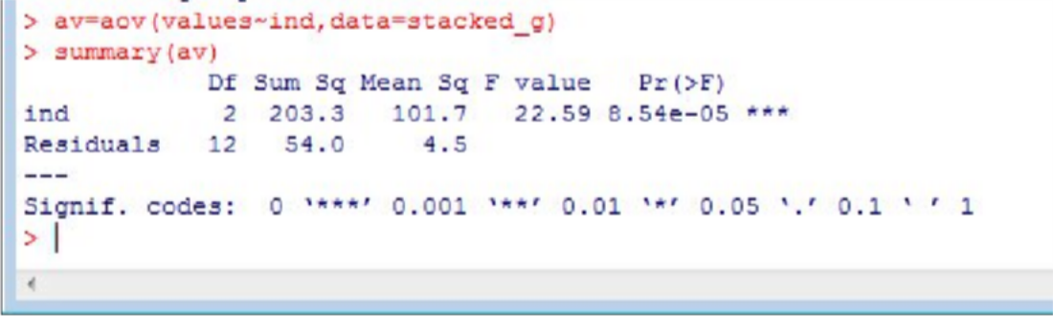

### 2. TAKE ANOTHER DATASET AND WORK ON THAT.

**# CREATE THE DATA IN TO THREE GROUPS**

> g1=c(29,30,31,31,29)

> g2=c(28,29,27,30,29)

> g3=c(25,28,29,27,29)

* cg1=data.frame(cbind(g1,g2,g3))
* cg1

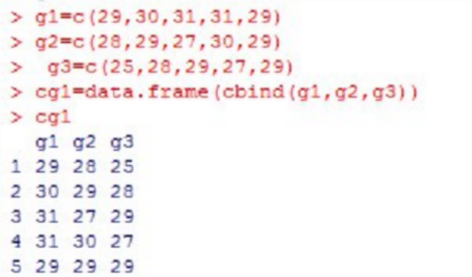

### #TO PRINT THE DATA INTO STACK FORMATE

>stacked_g=stack(cg1)

>stacked_g

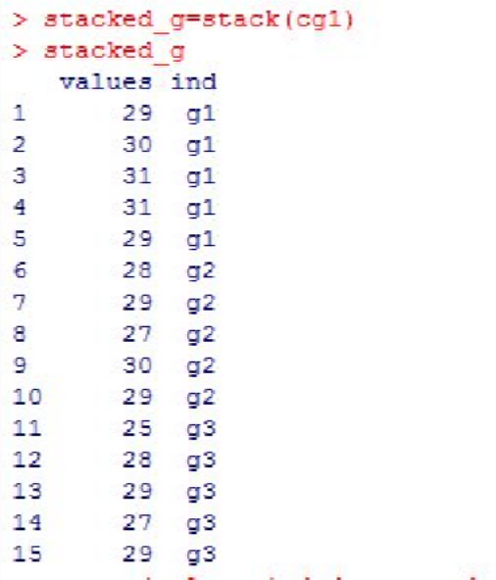

### >av=aov(values~ind,data=stacked_g)

**>summary(av1)**

